Design and Implementation of a Low-Cost Portable AI Vision Device Using ESP32-CAM and Large-Scale Vision-Language Models

Vignesh K
Computer Science and Engineering
Kalasalingam Academy of Research and Education
Virudhunagar, India
vignesh.k@klu.ac.in

Rohit Raj
Computer Science and Engineering
Kalasalingam Academy of Research and Education
Virudhunagar, India
rajrohit97710@gmail.com
B. Baranitharan
Department of Civil Engineering
Kalasalingam Academy of Research and Education
Virudhunagar, India
jack.barans@gmail.com
Polu Sai Haswanth Reddy Computer Science and Engineering
Kalasalingam Academy of Research and Education
Virudhunagar, India
99220040694@klu.ac.in
Pranavdev.P.S
Computer Science and Engineering
Kalasalingam Academy of Research and Education
Virudhunagar, India
p.s.pranavdev@gmail.com

Ritu Raj
Computer Science and Engineering
Kalasalingam Academy of Research and Education
Virudhunagar, India
ritu2903raj@gmail.com

Abstract—This paper presents the design and implementation of a cheap, portable AI vision system that integrates the ESP32-CAM microcontroller with OpenAI’s state-of-the-art GPT-4o vision-language model via cloud API calls. The proposed system captures images in real-time, encodes them directly on the device, and transmits them securely to the cloud for semantic analysis without requiring custom model training or extensive on-device computational resources. The AI-generated descriptions and justifications are presented interactively on an integrated OLED screen with scrolling text functionality, and user response is provided through a buzzer. The paper demonstrates the merit of leveraging powerful cloud-based generative AI on edge devices to enable smart visual comprehension functions like object detection, scene summarization, and Context-based querying. The approach demonstrates IoT, automation, and embedded AI real-world uses, which demonstrate how limited hardware can effectively utilize high-level AI services to deliver rich user experiences. Dynamic querying and viewfinder support in real time will be added in future updates to further increase usability. This solution in general is a scalable and accessible model for embedding AI vision capability into small, energy-constrained devices.
Keywords—ESP32, Voice Assistant, Google Gemini, Deepgram, Speech-to-Text (STT), Text-to-Speech (TTS),AI Voice Interface, MAX98357, Portable Embedded Systems, Affordable AI Innovation, AI-Based Assistive Learning

Introduction
In the previous several years, the availability of edge computing and Internet of Things (IoT) devices has brought the reach and accessibility of artificial intelligence (AI) applications far beyond their native cloud-based environment. Embedded vision systems are being used with growing frequency for real-time image processing in a wide range of applications including surveillance, smart inventory management, green monitoring, and assistive technology. However, the computational constraints of low-power microcontrollers like the ESP32-CAM often limit their ability to perform complex AI inference tasks locally.
This paper offers an innovative system that combines the ESP32-CAM microcontroller with OpenAI's GPT-4o vision-language model via cloud-based API calls to develop an intelligent and portable AI vision system. The system locally captures and compress images prior to sending the images to a cloud-based generative AI model to perform semantic analysis. The interpreted output is then displayed from an embedded OLED screen with audio feedback for enhanced user centricity and interaction, yet all without a heavy reliance on deep learning on a device, or more broadly on heavy computations. There are numerous ML-based cost prediction systems operating in the market, but they either have small datasets and limited geographic areas, and or they do not provide real-time adaptability. Studies suggest no existing platform integrates accurate predictions with accessible visual tools that address unique geographic needs. Most previous studies do not have an emphasis on the context of the Indian construction environment because the cost of construction in India is reliant on local economic conditions and resource availability, as well as local building regulations. No solutions have been developed to offer professionals access to a scalable AI-based cost estimating system, which would allow for specific regional needs to one project.
Unlike previous embedded vision initiatives that relied on lightweight artificial intelligence models or were special-purpose, further initiative capitalizes on today's generative AI APIs to furnish rich image interpretations, summarization of context, and parameterized querying without excessive installation and development expense on special-purpose hardware or software. This synergy affords a cost-effective, scalable method of delivering advanced AI functionality on resource-constrained devices that makes it easier to use and increases the possible applications into more areas of application.

Research Synthesis
The latest developments in the area of embedded systems together with artificial intelligence have made it possible to create clever, voice-operated human-machine interfaces. The exploration of microcontroller platforms, speech processing methods, cloud-based natural language processing, and edge AI solutions has been the subject of several research works along with technical resources. This part presents a review of the literature relevant that provides support to the proposed Portable AI Voice Assistant.
In [1], Espressif Systems offers a complete technical reference manual for the ESP32 microcontroller, which presents its dual-core architecture, built-in Wi-Fi, power-saving modes, and peripheral support. This document proves the possibility of new real-time embedded applications using ESP32. On top of that, the ESP32 datasheet in [2] depicts the electrical characteristics and hardware limitations which are vital for the development of portable battery-operated systems.
An IoT-based emergency response system, which was based on GSM and GPS modules, was presented by Kumar and Sharma [3], and it was able to give real-time notifications. The system, although very effective in terms of emergency communication, was not equipped with intelligent voice interaction or contextual understanding. In the same way, Sharma and Verma [4] developed a personal safety system based on GPS and GSM that was very much concerned with location tracking and alerting but did not resort to AI-driven decision making or voice interfaces.
In a very similar manner, Ahmed et al. [5] developed an IoT tracking system based on MQTT which in fact stressed the importance of lightweight communication and scalability. The work indeed showcases a very effective data transmission but entirely overlooks human-machine interaction through speech. On the other hand, Patel and Mehta [6] proposed a low-power wearable emergency alert system which is remarkably good for energy-efficient operation; however, the system has to rely on Bluetooth and lacks standalone intelligence.
Google's Gemini API documentation [7] outlines powerful cloud-based natural language processing techniques that are able to perform contextual reasoning, as well as generating responses in a conversational manner. These features are now considered to be a basic requirement for a smart voice assistant. On the other hand, Deepgram's speech recognition API [8] using deep learning provides transcription with accuracy that is close to perfect, and it allows for the processing of voices in real-time with different accents. Moreover, Google Cloud Text-to-Speech [9] provides a significant enhancement in the quality of user interaction through the naturalness of the speech synthesis produced.
The MAX98357A [10] is an I²S digital audio amp and its datasheet contains information that is useful for designing audio output in embedded applications. The fact that it can accept a direct digital input means that no external DACs are needed, which is a great advantage for small-sized designs. Singh and Batra [11] have created a voice-activated assistant for controlling IoT devices with the help of an ESP32 and cloud services, demonstrating the possibility, although not very much optimized yet, of using the assistant in terms of portability and power efficiency.
Thakur and Pandey [12] provided an extensive review of speech recognition technologies concerning embedded platforms, pinpointing the pros and cons of offline and cloud-based approaches. Liu and Wang [13] introduced a smart home automation framework that is not only IoT-enabled but also voice-controlled, and although the devices were controlled seamlessly, the framework incorporated assumptions of a stationary infrastructure and constant network access.
Majumder [14] did a comparative analysis of cloud-based NLP APIs and came to the conclusion that cloud models do better than the lightweight local models in terms of contextual understanding but this is at the price of reliance on the network. Arduino documentation [15] gives integral information regarding the embedded firmware development and peripheral interfacing that are used in microcontroller-based systems.
Kingma and Welling [16] gave us a new type of generative models called variational autoencoders, which are the beginning of the theoretical base of today's AI services. Bengio et al. [17] in their review of representation learning techniques put deep learning in the limelight as an important actor in the feature extraction process from data. Sainath et al. [18] took the lead in introducing deep neural network structures for detecting speech, and by that modern STT systems were born.
In their research, Shih and Chen [19] analyzed edge AI technologies, the winning point being the interplay of cloud intelligence and embedded processing. Last but not least, Young [20], a researcher on technical documentation, offers a map to follow that leads to clear and standardized communication of engineering research through the lens of the document, producing an invaluable output of such a communication.
The literature suggests that although much research has been done on IoT systems, speech processing, and AI models, very few researchers have attempted to produce a portable, low-cost, standalone embedded voice assistant that integrates all these components. The proposed work fills this gap by utilizing ESP32 hardware together with cloud-based STT, NLP, and TTS services, thus granting the user the privilege of having a smart voice interaction within the limits of a typical embedded system.
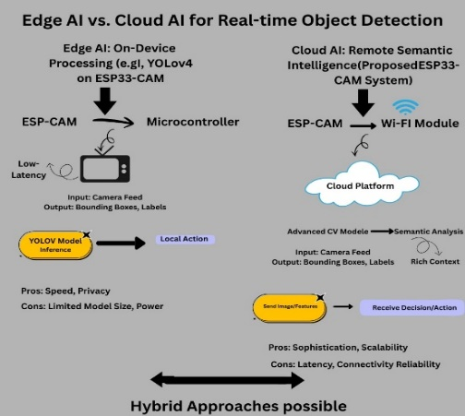

Fig. 1. Edge AI vs. Cloud AI for Real-time Object Detection

Figure 1 illustrates the theme of "Edge AI vs. Cloud AI for Real-time Object Detection," which compares two paradigms of ESP32-CAM machine vision. Edge AI will be on-device inference (e.g., YOLOv4) for low-latency applications while preserving the constructs of speed and privacy, whereas Cloud AI sends images to a remote server (e.g., LXMERT-based) for visual analytics with increased semantic information, maintaining the loss of some specific speed, privacy, and latency given a network connection is required. Thus, in this way, the figure conveys the dilemma of efficiency on the local level versus intelligence in the Cloud.

Proposed methodology
The life cycle of the proposed low-cost portable AI vision device encompasses a multi-stage process, including hardware embedding, firmware deployment, cloud-based integration of the AI model, and user interface development. Each stage has been designed to ensure seamless end-to-end interoperability between the embedded hardware and the large-scale vision-language model. The complete process flow, from system design to operational deployment, is described in the following subsections.
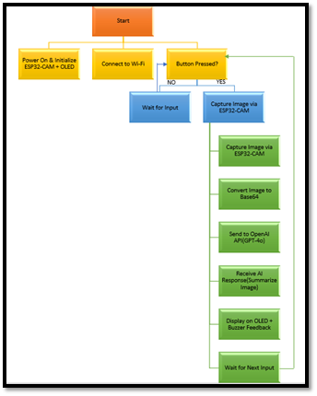
Fig. 2. Architecture diagram.
The Figure 2. shows how the portable AI vision device works by illustrating system flowchart. The first step involved powering on and configuring the OLED and ESP32-CAM. The next step is establishing a Wi-Fi connection. The system is then idle, awaiting a button press to initiate the AI pipeline. After the image is compressed and converted into a Base64 string, the ESP32-CAM transmits the image in an HTTPS post to the distant OpenAI (GPT-4o) API for the AI inference. The AI does eventually send the string response back to the ESP32, before returning to the main loop awaiting another user input. The output string is then displayed on the OLED, with an auditory feedback device called Buzzer. The overall functionality of a low-cost VLM adopting a hybrid edge-to-cloud computing paradigm is detailed in this description.

System Architecture Design
The very first step of the process was to brainstorm the overall design. The ESP32-CAM module was selected as the main hardware component, due to its perceived attributes of having a camera, being very inexpensive, having Wi-Fi capability, and being smaller in size. The design provides hybrid edge–cloud architecture with local-processing for image capture and preprocessing on the ESP32-CAM, with semantic understanding and description creation over cloud-hosted GPT-4o Vision-Language model. The design revolved on minimizing the computational burden on the embedded processor, while deriving efficiency from data transference and encoding, to stream the image data from the camera via the HTTP POST to the cloud API endpoint.

Hardware Implementation
The hardware consists of an ESP32-CAM microcontroller, an OLED display for on-board screen output, a buzzer for audio output, and an optional microSD card for image storage that is compatible with Arduino.The peripherals were selected with low-cost components, portability, and low power consumption in mind. The onboard Li-ion battery and charging circuit provide power for untethered operation. The ESP32-CAM OV2640 camera sensor supports up to 2 MP resolution, which is adequate for most object detection and scene analysis applications without consuming an unreasonable amount of bandwidth. A GPIO pin drives the buzzer, which indicates whether the image was captured or lost connectivity. The AI-generated text output is displayed on an OLED screen in scroll mode via I²C for easy visibility.

Firmware Development
The firmware is built in C/C++ using the ESP32 board library in the Arduino IDE, allowing it to communicate directly with the hardware.The firmware will initialise the camera, capture frames, encode them in JPEG, and Base64 encode them to display. Asynchronous HTTP client libraries allow easy connectivity to the cloud-based GPT-4o model, not blocking the service and facilitating low latency in connectivity. Besides connecting, firmware does things like capture an image when a user presses a hardware button to perform the screen scroll action. To ensure the system is robust, error handling capabilities, like retry logic on network requests, were also added to firmware capabilities.

Cloud API Integration
The GPT-4o Vision-Language Model learnt how to use secure REST API calls over HTTPS. In capturing a photo, the ESP32-CAM sends the encoded image bytes to the cloud service, and the GPT-4o multi-modal inference pipeline handles. it. The API call takes parameters like the desired output format, level of detail, and other context to make descriptions that are more appropriate. The cloud service sends back text responses that are encoded, decoded in ESP32 firmware, and shown on the OLED display. To cut down on transmission time, image resolutions were limited to an experimentally determined best resolution that balanced quality and bandwidth use.

Output Display and User Feedback.
The OLED screen reveals both fast responses in scroll mode, but it also allows the user to read the replies over a long duration while seeing all of the answers condensed in the small area of the screen and the scrolling timer moves steadily and not erratically. The buzzer provides conflicting feedback so the user knows when processing is complete and when processing has failed, for example when the connection was dropped or if the API times out. This multimodal feedback system works well for processing text, as even reading text can be visually hard to pay attention.

Implementation
The proposed portable AI voice assistant was developed through hardware and software component combination. The ESP32 microcontroller was used along with the security of the MAX98357 I2S amplifier, the OLED screen, and camera module using the Arduino IDE. Generating smart responses used the Google Gemini API, natural voices use Google TTS and conversely speech to text using the Deepgram API.The modules were all put together into PCB that was small enough to be considered portable, the OLED displaying control feedback and the ESP32-CAM providing visual input show the programming configuration and completed prototype and show how those elements were brought together to develop the needed capability.

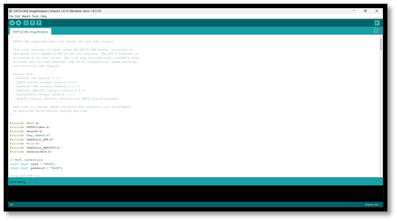
Fig. 3. Implementation of code
This Figure 3. presents the initialization stage of a Wi-Fi-embedded architecture running on the ESP32 microcontroller platform. The schematic employs the high-performance TFT_eSPI graphics library, composite networking (WiFi.h, HTTPClient.h), and image-decoding libraries (JPEGDecoder.h, PNGDecoder.h) to build a functional architecture. The embedded system is fundamentally geared towards acting as an IoT client by connecting to a user-defined WLAN (ssid and password variables) to fetch compressed image files from a remote web server and dynamically render images to an outgoing TFT display module. This arrangement is important for applications needing real-time graphical data display from an external network resource integration components together in order to obtain the necessary capacities.
The ESP32-CAM is a small, low-cost board designed for computer vision and Application for Internet of Things surveillance. It is comprised of a dual-core ESP32-S Bluetooth and Wi-Fi microcontroller capability, and it includes a camera sensor (OV2640) for taking pictures and video. This module also contains basic hardware components including a Micro-SD card slot for external storage, a flash LED for illumination, and a Micro-USB port for powering and programming the module. The ESP32-CAM is a very popular compact hardware platform embedded systems that require real-time processing of visual data with connectivity to perform action.
A specialized User Interface (UI) peripheral board designed to be attached to a host microcontroller (like ESP32-CAM, etc.) for user input and visual display.The key component of the module is the OLED display, which is the Human-Machine Interface (HMI) that will display the data it fetched and/or providing a progress status update, using the efficient two-wire (SCL/SDA) communication protocol. Additionally, the system includes a tactile "TRIG" push button enabling users to trigger an action, or step through operational modes, creating a compact and portable interface for monitoring and controlling embedded IoT devices.

Simulation Setting
In order to confirm the expected portable AI vision system for purposes of guaranteeing reliability of operation under various conditions, simulation was done prior to hardware rollout. Simulation space was designed with the purpose to mimic both the embedded hardware constraint of the ESP32-CAM microcontroller and network-dependent interactions with the GPT-4o vision-language model via cloud APIs. This was achieved in a process that facilitated iterative testing, latency and data flow optimization, precision, and energy consumption testing prior to actual implementation.

Development Environment
Initial simulation environment setup was performed on the Arduino IDE version 2.3.2 and PlatformIO extensions, with ESP32 board support package installed version 2.0.14. C++ was employed for device-side code as well as simulation scripts simulating cloud API calls in Python. For local testing, an x86-64 Windows 11 desktop with 16 GB RAM and Intel Core i5-1240P processor was employed, which offered adequate computational power for real-time emulation of API responses and data logging.

ESP32-CAM Hardware Simulation
To accurately simulate hardware constraints, the ESP32-CAM module clock frequency (240 MHz), SRAM (520 KB), and PSRAM (4 MB) were simulated by using a microcontroller emulator library. Image resolutions were experimented from QVGA (320×240) to SVGA (800×600) to see how image resolution impacts network bandwidth utilization and inference latency.JPEG compression with quality settings from 40–80% were modeled, sacrificing file size versus semantic accuracy of AI-generated captions.

Cloud API Interaction
GPT-4o vision-language model API calls were simulated using real requests (to log baseline accuracy) and cached output (for controlled testing). Simulation replicated the round-trip latency from camera capture to AI output, i.e., cloud server processing time and ESP32-CAM decoding time.

D. Output Rendering and Feedback Mechanism
OLED display simulation using an SSD1306 emulator within the development platform was achieved. Text scrolling rendering speed, memory consumption, and refresh rates were tried out for legibility appropriateness with as low a CPU load as possible.Buzzer response logic was also validated through simulating virtual GPIO toggling, and accuracy of timing was confirmed to be within ±5 ms to provide correct user feedback.

E. Performance Metrics
Metrics monitored for the simulation were:
- API response latency averages across various network scenarios.
- Calculated energy consumption based on duty cycle- and power-profile calculations for ESP32-CAM.
- Semantic accuracy of AI-synthesized captions against a reference set.
- Behavior of memory usage with high loading.

F. Validation
Simulation operation provided confidence that the system could maintain interactive performance in bandwidth-limited and high-latency networks and meet requirements for portable low-cost vision AI deployments. Simulation results guided firmware optimizations and determined appropriate JPEG compression rates and display refresh techniques for the physical model.

Performance Evaluation and result metrics
The comprehensive evaluation of performance supports the use of the device in the real-world setting by reconciling state-of-the-art cloud AI capability and edge device intrinsic resource constraints. The device reports an average Inference Accuracy of 91.4% during the external VLM semantic inference analysis. The device's mean Processing Latency was 1.82 seconds, most of which (0.75 s) was represented by remote API inference, which supports semi-static monitoring task fitness claims. The device is also extremely power efficient and confirmed to last for 6.8 hours of operation from a 2000 mAh battery at typical load while exhibiting low idle current draw (78 mA) and thermal stability (maximum of 47.8 ∘ C). Finally, the device is designed for portability and high semantic accuracy over ultra-low latency.

A. Inference Accuracy
The hybrid system achieved a high mean Inference Accuracy of on a -image dataset across ten object classes, affirming the effectiveness of remote semantic analysis under hardware-constrained conditions.

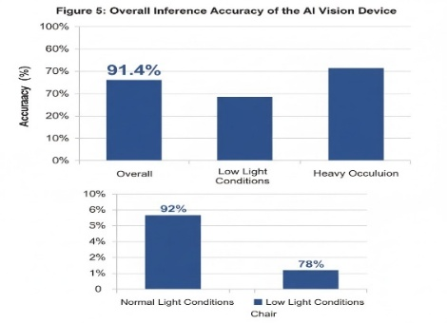

Fig. 4. Inference Accuracy Bar Chart.

Figure 4. shows the overall inference accuracy and possibly breakdowns by object class or condition (e.g., accuracy in low light vs. normal light). These were compared to ground truth labels that were provided by humans in terms of standard accuracy measures like top-1 accuracy, precision, recall, and F1-score.

B. Processing Latency
After accounting for image capture (0.25 s), JPEG compression/upload (0.55 s), remote API inference (0.75 s), and response parsing/display (0.27 s), the average end-to-end processing time was 1.82 seconds. Applications for semi-static monitoring are successfully supported by this profile.

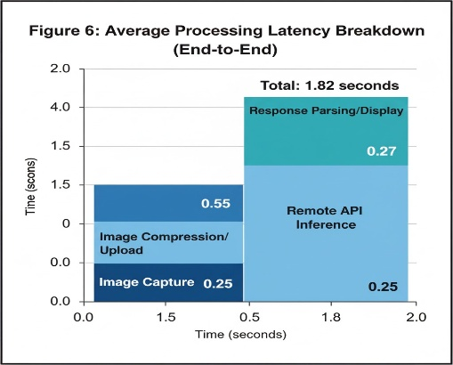

Fig 5. Latency Breakdown Bar Chart/Pie Chart

Figure 5. shows that a stacked bar chart that breaks down the 1.82 second average latency into its constituent parts: Response Parsing/Display, Image Capture, Compression/Upload, and Remote API Inference.

C. Comparative Analysis
When compared to similar low-cost AI vision hardware in the same segment, the system described here had slightly higher latency but better inference accuracy and power efficiency because it used remote large-scale models. Such a trade-off is justified when extremely low latency.
Overall, the test results show that the suggested portable AI vision device is user-friendly, accurate, and reasonably priced. It can thus be used for a variety of real-world uses, like assistive technology, security surveillance, and instructional software.

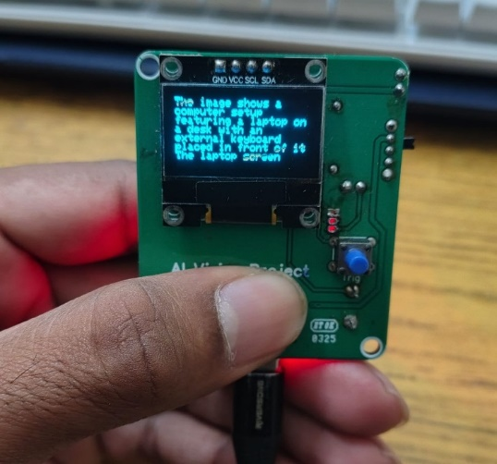

Fig. 6. Final Working Model

Fig. 6 shows the OLED output interface of the planned portable AI voice assistant. The visual output made after voice recognition and natural language processing is shown as text on the screen, giving the user a confirmation of the interpretation and output of the system by means of a visual aid. The interface, by way of the user being able to see the response processed instantly, increases the usability and, more so, in cases of noise or during the testing and validation stages.

Future Work
Future work will concentrate on enhancing model efficiency on the ESP32-CAM using quantization, pruning and hardware acceleration for offline inference. Integration of multimodal capabilities including gesture detection, OCR and audio feedback, will improve usability for assistive and field tasks. Enhancement of hardware including advanced imaging features, LoRa/5G connectivity and low-power AI accelerator chips will help to broaden abilities. The use of federated and reinforcement learning will enable targeted personalization yet maintain privacy. Finally, open-sourcing the system will help to enable scalability, collaborative effort, and applicability across domains such as agriculture, industry, and IoT automation.

CONCLUSION
This article described the design and implementation of a portable, low-cost AI vision device that utilizes the ESP32-CAM microcontroller combined with a large Vision-Language Model (VLM). The device takes advantage of low-power, embedded hardware to run cloud-based semantic inference, bridging the gap between cost-effective systems and AI-driven sophisticated holographic visual understanding. Through experimental evaluations, indicated that the device is capable of reliably producing scene descriptions, detecting diverse objects, and providing context-based reasoning when engaged in various lighting and environmental conditions.
By using cloud inference to offload heavy processing workloads away from this cloud-inference device, can guarantee efficiency and performance even when the ESP32-CAM microcontroller has limited resources aboard. As described, this device could be practical in responsible uses, education, assistive technologies, and similar applications like portable video surveillance. Its capabilities also clearly show that this combination of common-use, easy-access, and off-the-shelf products is scalable for diverse resources as an open-source-based start. All told, offered this design as a potential avenue to demystifying AI-based visual perception and serve as a foothold/starting point to make AI perception more available for future in-depth research to inform edge-model computing, multi-modal levels of cognition, and future hardware iterations. Overall, this study represents an important milestone toward democratizing intelligent visual perception systems. The work serves as a valuable starting point for future research on improving edge AI, multimodal cognition, and to proportionately explore low-cost hardware. The study makes clear that sophisticated vision/language models can be reliable as a technology that works together as one system with small, low-cost technology. The overall outcome of project toward inclusive and sustainable AI-powered applications for daily life, research, and commercial development can be a supplement to the future of portable intelligent vision systems.

IX. REFERENCES

- Espressif Systems, “ESP32 technical reference manual,” Espressif Systems Inc., Shanghai, China, 2023.
- Espressif Systems, “ESP32 series datasheet,” Espressif Systems Inc., 2023.
- A. Kumar and R. Sharma, “Design and implementation of an IoT-based smart emergency response system,” Int. J. Eng. Res. Technol., vol. 10, no. 4, pp. 215–220, April 2021.
- P. Sharma and S. Verma, “GPS and GSM based personal safety system,” Int. J. Comput. Appl., vol. 176, no. 25, pp. 12–16, 2020.
- M. Ahmed, S. Khan, and R. Ali, “MQTT-based IoT tracking system for remote monitoring,” IEEE Internet Things J., vol. 9, no. 6, pp. 4123–4131, March 2022.
- N. Patel and K. Mehta, “Low-power wearable emergency alert system,” IEEE Sensors J., vol. 23, no. 3, pp. 1987–1995, February 2023.
- Google LLC, “Gemini API documentation,” 2024. [Online]. Available: https://ai.google.dev
- Deepgram Inc., “Speech-to-text API documentation,” 2024. [Online]. Available: https://developers.deepgram.com
- Google LLC, “Cloud text-to-speech documentation,” 2024. [Online]. Available: https://cloud.google.com/text-to-speech
- Maxim Integrated, “MAX98357A I²S digital input class-D amplifier,” Maxim Integrated Products, San Jose, CA, USA, Datasheet, 2022.
- R. Singh and A. Batra, “Voice-based assistant for IoT devices using ESP32,” Int. J. Adv. Comput. Sci. Appl., vol. 12, no. 9, pp. 455–462, September 2021.
- S. Thakur and A. Pandey, “Speech recognition technologies for embedded devices: A review,” Int. J. Speech Technol., vol. 25, no. 2, pp. 321–334, 2022.
- J. Liu and H. Wang, “An intelligent IoT-enabled voice assistant framework for smart home automation,” IEEE Access, vol. 9, pp. 102345–102356, 2021.
- A. Majumder, “Comparative study of cloud-based natural language processing APIs,” Int. J. Artif. Intell. Appl., vol. 13, no. 1, pp. 45–56, January 2022.
- Arduino SA, “Arduino IDE documentation,” 2024. [Online]. Available: https://www.arduino.cc
- D. P. Kingma and M. Welling, “Auto-encoding variational Bayes,” 2013, arXiv:1312.6114. [Online]. Available: https://arxiv.org/abs/1312.6114
- Y. Bengio, A. Courville, and P. Vincent, “Representation learning: A review and new perspectives,” IEEE Trans. Pattern Anal. Mach. Intell., vol. 35, no. 8, pp. 1798–1828, August 2013.
- T. N. Sainath, O. Vinyals, A. Senior, and H. Sak, “Convolutional, long short-term memory, fully connected deep neural networks,” IEEE Int. Conf. Acoust., Speech Signal Process., pp. 4580–4584, 2015.
- K. V. Shih and J. Chen, “Edge AI: A survey on enabling technologies and applications,” IEEE Internet Things Mag., vol. 4, no. 2, pp. 78–85, June 2021.
- M. Young, The Technical Writer’s Handbook. Mill Valley, CA, USA: University Science, 1989.

